Constant Intensity Shading

A fast and straightforward method for rendering an object with polygon surfaces is constant intensity shading, also called Flat Shading. In this method, a single intensity is calculated for each polygon. All points over the surface of the polygon are then displayed with the same intensity value. Constant Shading can be useful for quickly displaying the general appearances of the curved surface as shown in fig:

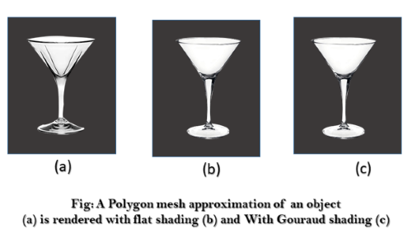

In general, flat shading of polygon facets provides an accurate rendering for an object if all of the following assumptions are valid:-

The object is a polyhedron and is not an approximation of an object with a curved surface.

All light sources illuminating the objects are sufficiently far from the surface so that N. L and the attenuation function are constant over the surface (where N is the unit normal to a surface and L is the unit direction vector to the point light source from a position on the surface).

The viewing position is sufficiently far from the surface so that V. R is constant over the surface (where V is the unit vector pointer to the viewer from the surface position and R represent a unit vector in the direction of ideal specular reflection).